Updated Layout of Angular Todo

1)Login

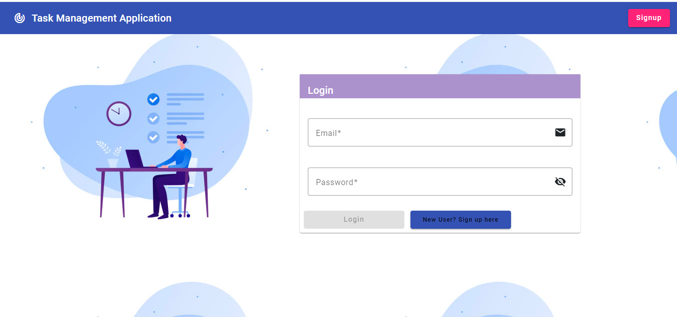

2)Signup

3)Task

